**React Assignment**

Q.1

import logo from './logo.svg';

import './App.css';

function App() {

  return (

    <div className="App">

      <header className="App-header">

        <img src={logo} className="App-logo" alt="logo" />

        <p>

          Hello World!--Welcome Shubhangi!

        </p>

        <a

          className="App-link"

          href="https://reactjs.org"

          target="_blank"

          rel="noopener noreferrer">

          Learn React

        </a>

      </header>

    </div>

  );

}

export default App;

Output:

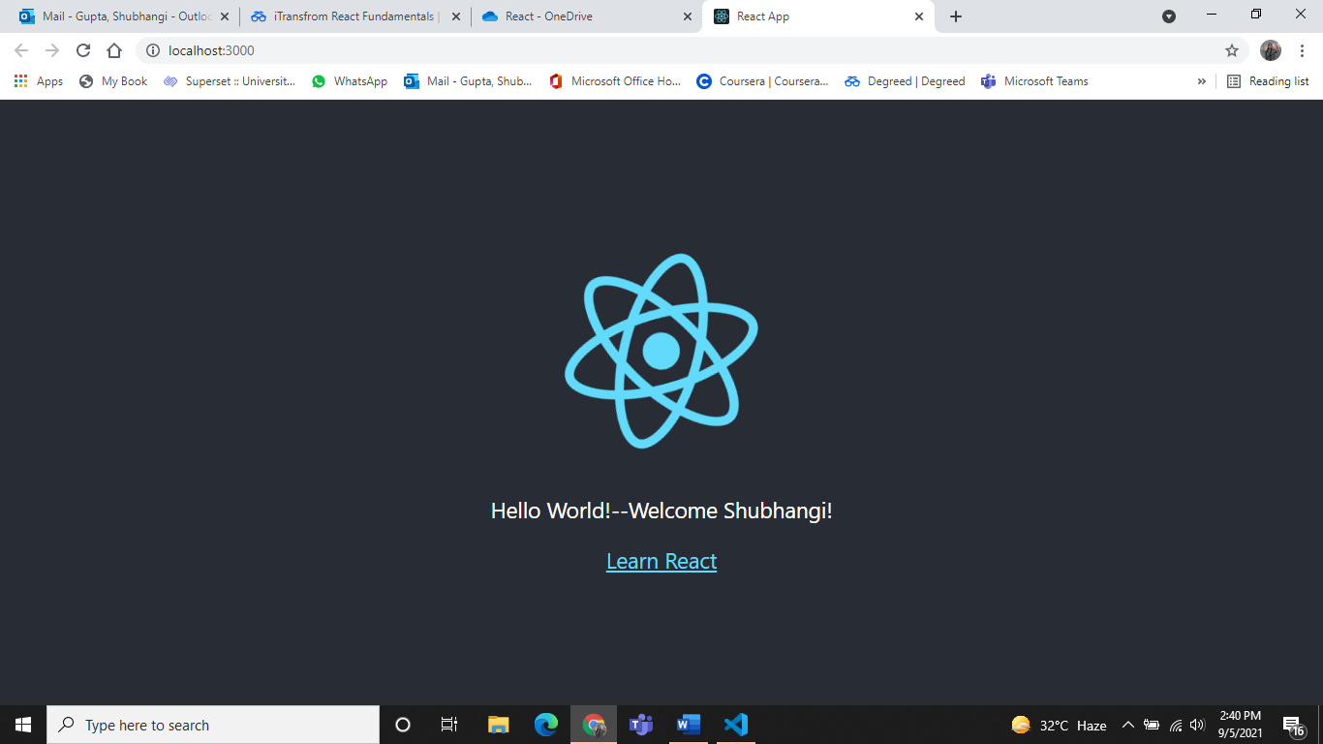

Q.2

import React from 'react'

function EmployeeTable() {

    return (

        <div>

            <table>

            <tr>

                <th>Name </th>

                <th>Job </th>

            </tr>

            <tr>

                <td>Shubhangi</td>

                <td> Student</td>

            </tr>

            <tr>

                <td>Charlie</td>

                <td> Janitor</td>

            </tr>

            <tr>

                <td>Mac</td>

                <td> Bouncer</td>

            </tr>

            <tr>

                <td>Dee</td>

                <td>Aspiring actress</td>

            </tr>

            <tr>

                <td>Dennis</td>

                <td> Bartender</td>

            </tr>

         </table>

        </div>

    )

}

export default EmployeeTable

Output:

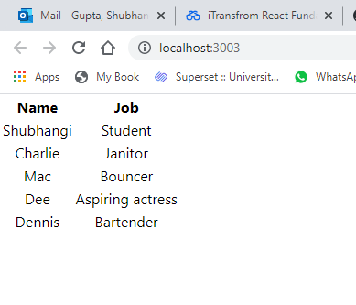

Q.4

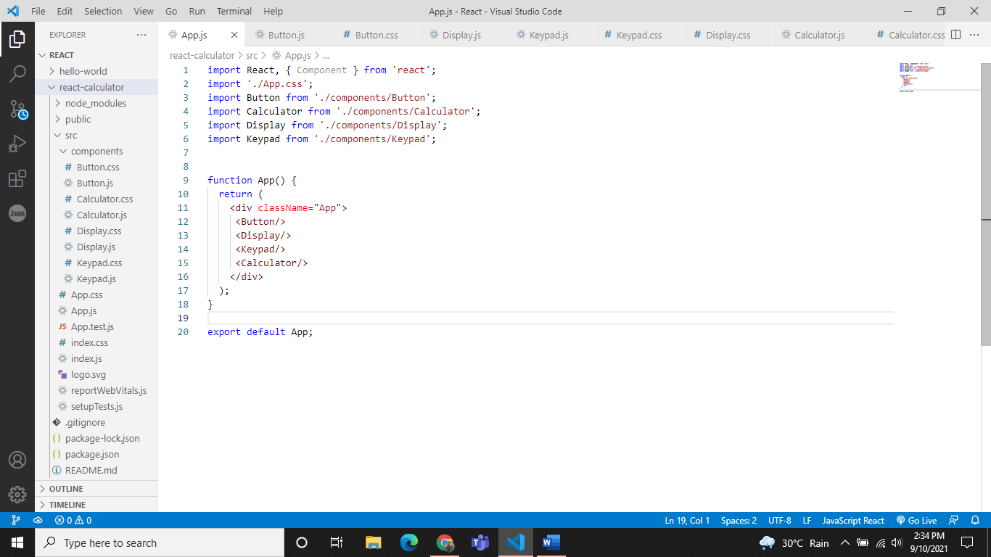

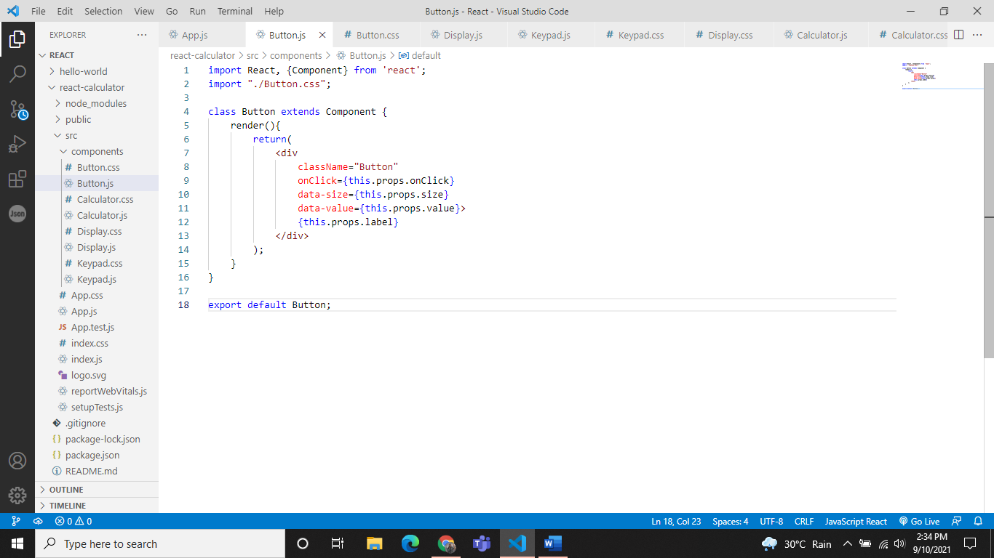

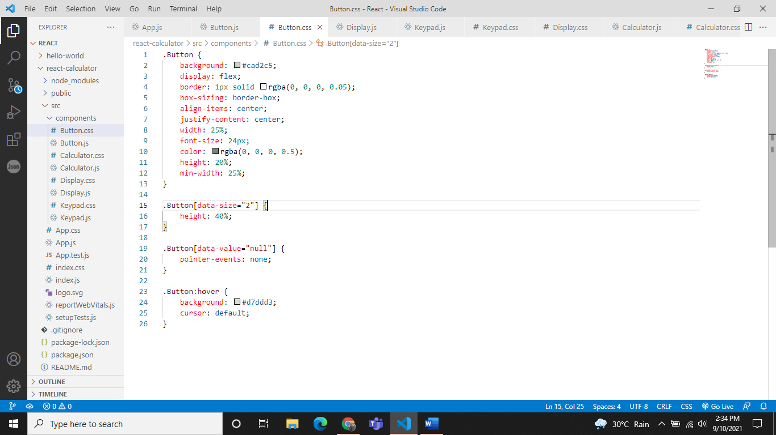

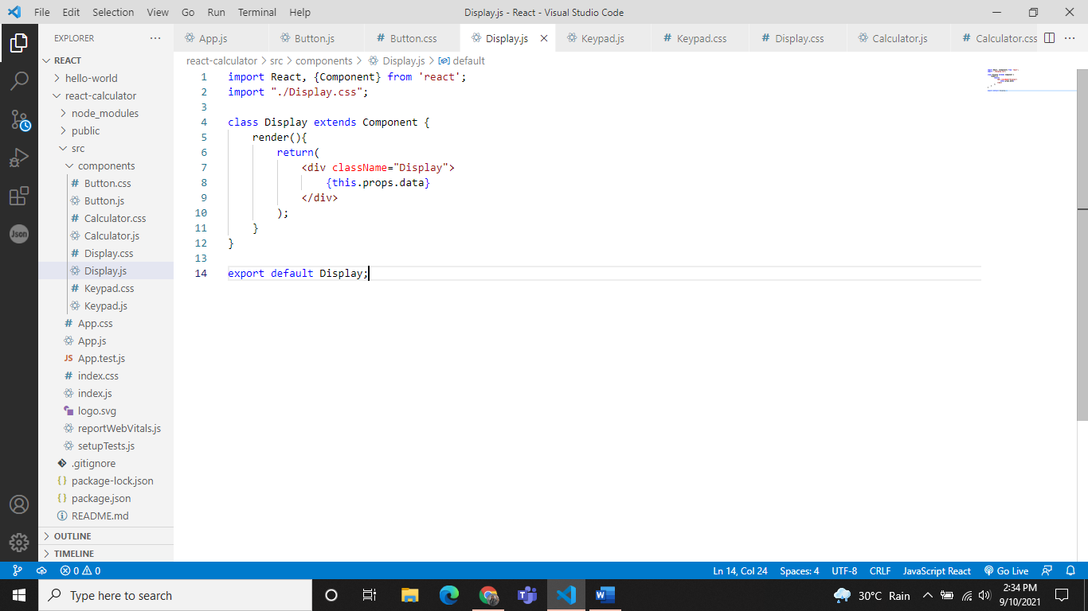

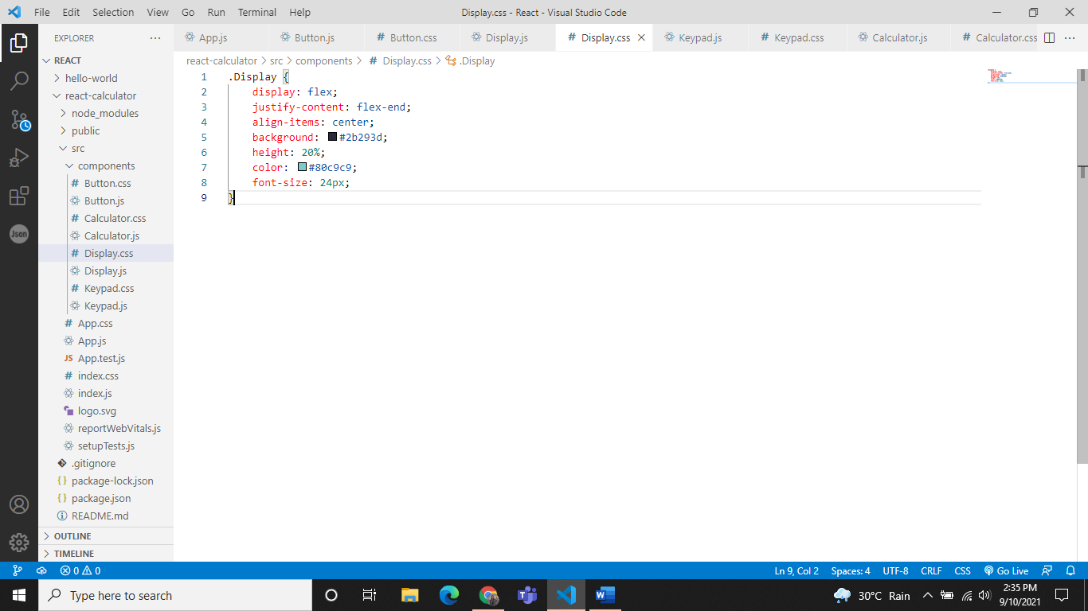

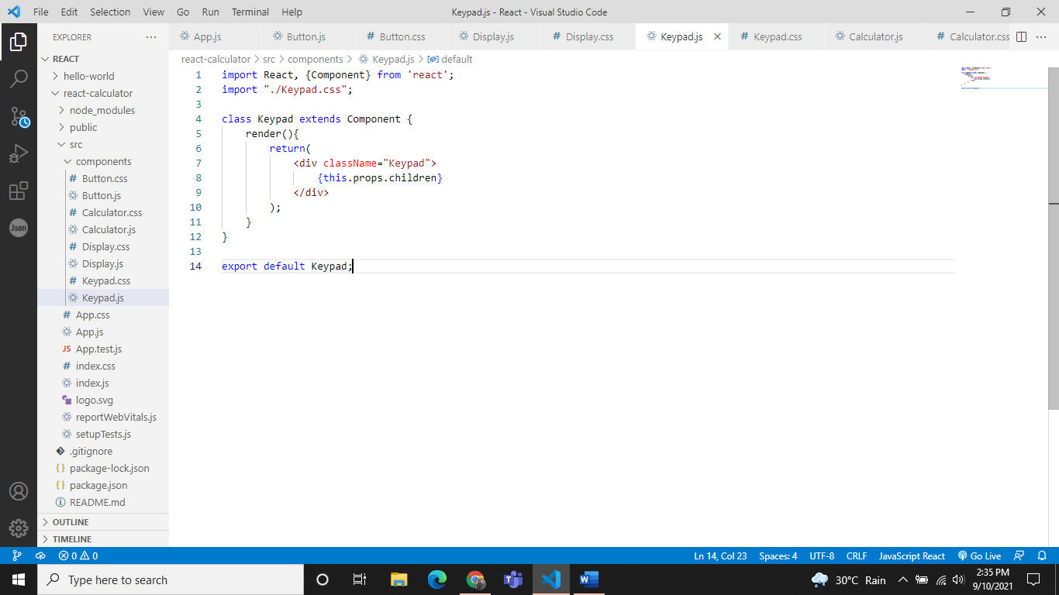

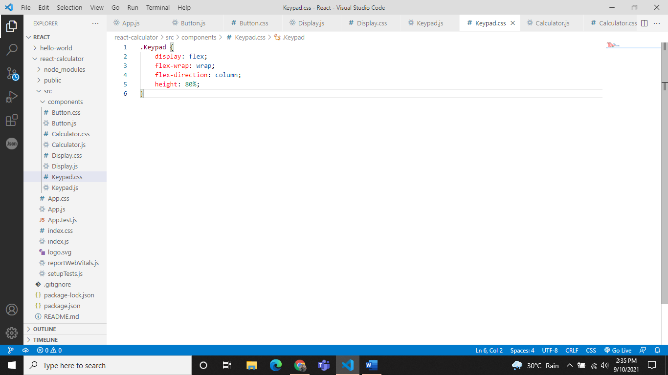

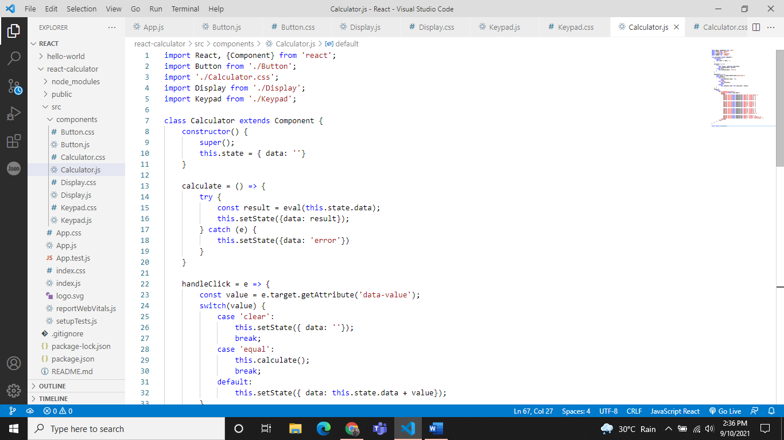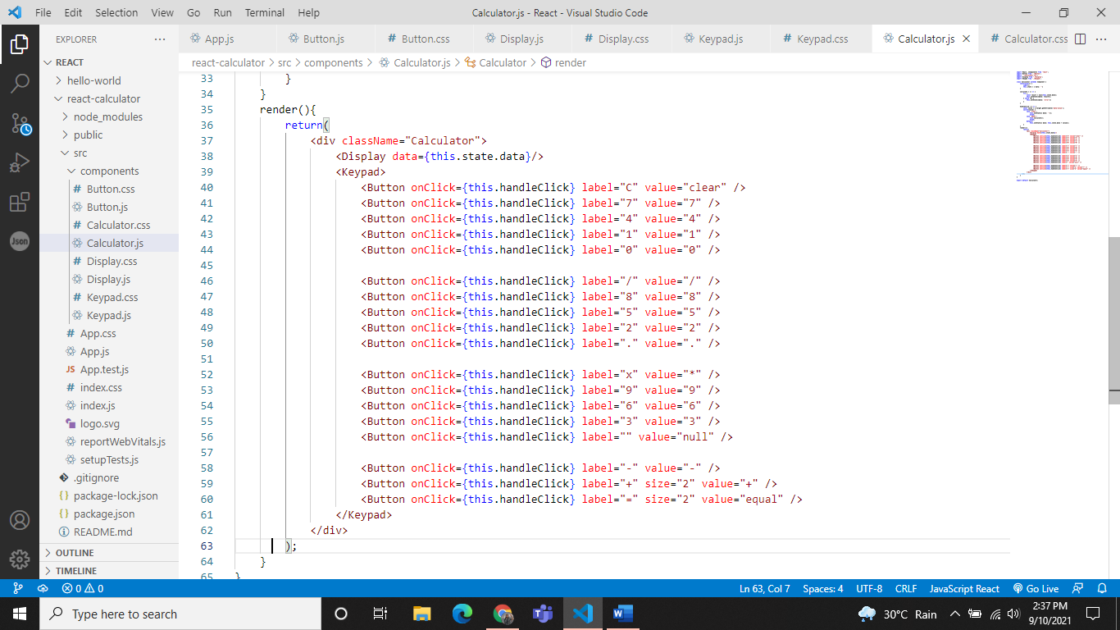

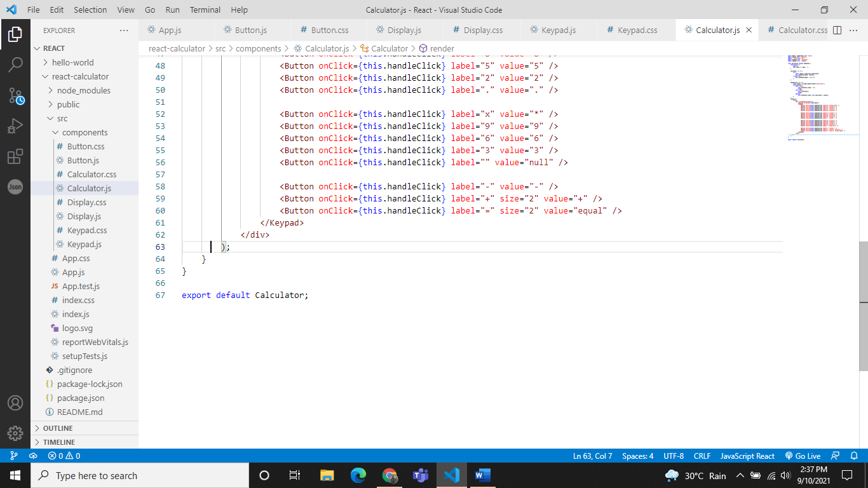

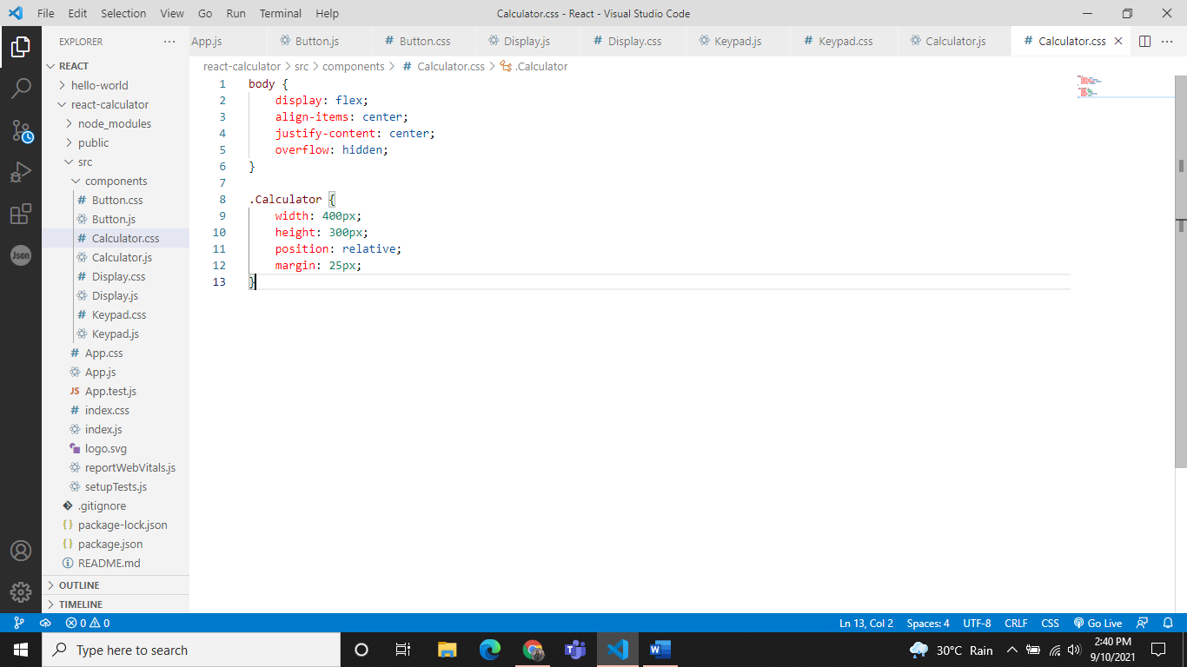

Output:

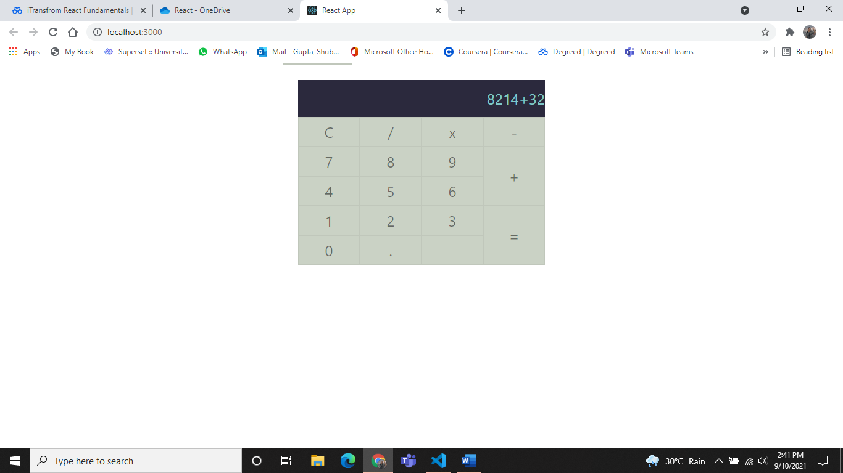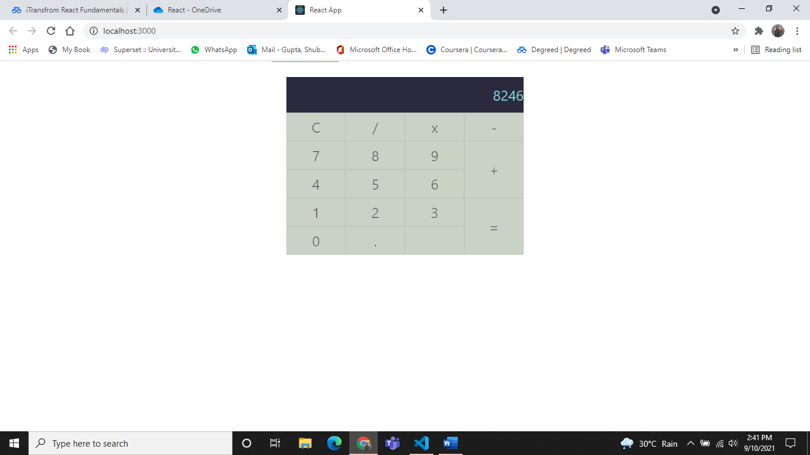

Q.6

import React, { Component } from 'react';

import './App.css';

import { BrowserRouter as Router, Link, NavLink, Redirect, Prompt} from 'react-router-dom';

import Route from 'react-router-dom/Route';

const User = (params) => {

  return ( <h1> Welcome User {params.username} </h1>)

}

class App extends Component {

  state = {

    loggedIn:false

  }

  loginHandle = () => {

    this.setState(prevState => ({

     loggedIn: !prevState.loggedIn

    }))

  }

  render() {

    return (

      <Router>

        <div className="App">

        <ul>

          <li>

            <NavLink to="/" exact activeStyle={

              { color:'green' }

            }>Home</NavLink>

          </li>

          <li>

            <NavLink to="/about" exact activeStyle={

              { color:'green' }

            }>About</NavLink>

          </li>

          <li>

            <NavLink to="/user/shubhangi" exact activeStyle={

              { color:'green' }

            }>User Shubhangi</NavLink>

          </li>

          <li>

            <NavLink to="/user/john" exact activeStyle={

              { color:'green' }

            }>User John</NavLink>

          </li>

          <li>

            <NavLink to="/user/peter" exact activeStyle={

              { color:'green' }

            }>User Peter</NavLink>

          </li>

          </ul>

          <Prompt

            when={!this.state.loggedIn}

            message={(location)=>{

               return location.pathname.startsWith('/user') ? 'Are you sure?' :

true

             }}

          />

        <input type="button" value={this.state.loggedIn ? 'log out': 'log in'} onClick={this.loginHandle.bind(this)}/>

        <Route path="/" exact strict render={

          () => {

            return ( <h1>Welcome Home</h1>);

          }

        }/>

        <Route path="/about" exact strict render={

          () => {

            return ( <h1>Welcome About</h1>);

          }

        }/>

        <Route path="/user/:username" exact strict render={({match})=>(

          this.state.loggedIn ? ( <User username={match.params.username}/>) : (<Redirect to='/' />)

        )}/>

        </div>

      </Router>

    );

  }

}

export default App;

Output:

